In the hidden layers Relu activation function is applied to increase the non-linearity in images and In the final dense layer **softmax activation is applied because it** allows the neural network to run a multi-class function (dog, cat, car etc.). I used a 3x3 filter starting with 32 filters and zero paddings and a stride of 1.

First structure

First the conv2d_1 using relu had an input volume of 32*32*3 and output shape of 32*32*32 it fired to another conv2d_2 using relu had an output shape of 32* 32* 32 then max_pooling2d_1 layer was applied with 16, 16, 32 output shape resulting in 8192 after flattening it then 1024 after applying a dropout of .2 and a dense layer using Relu activation function and finally an output shape of 10 after adding a dropout of .2 and applying a dense layer using softmax activation function (shown in fig 1)

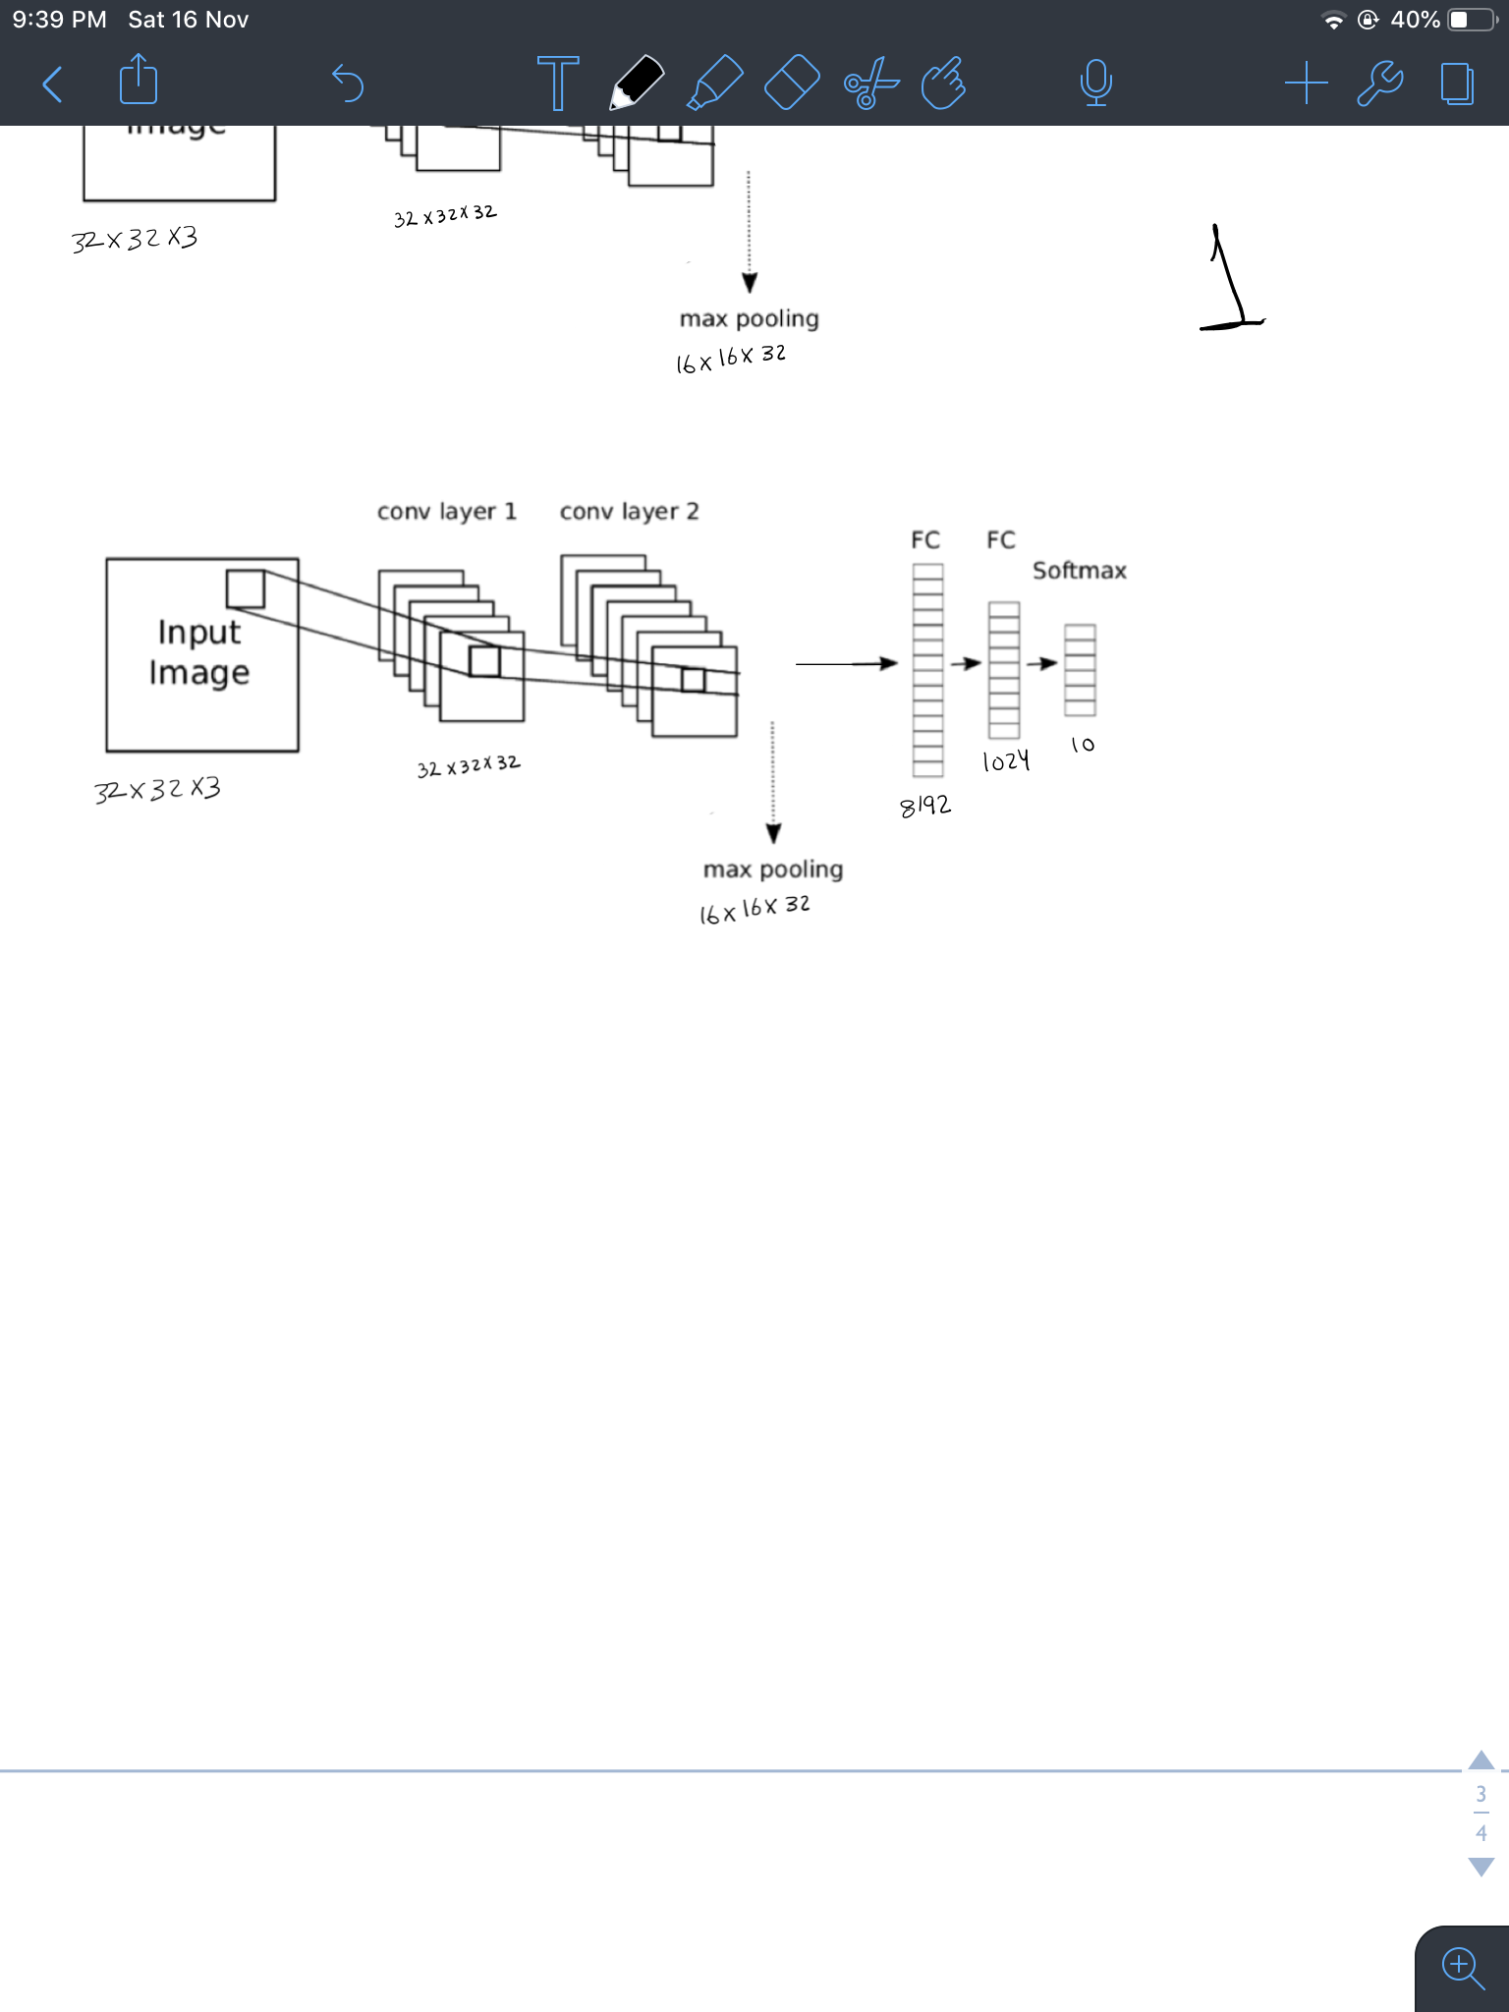

Fig 1

Confusion matrix:

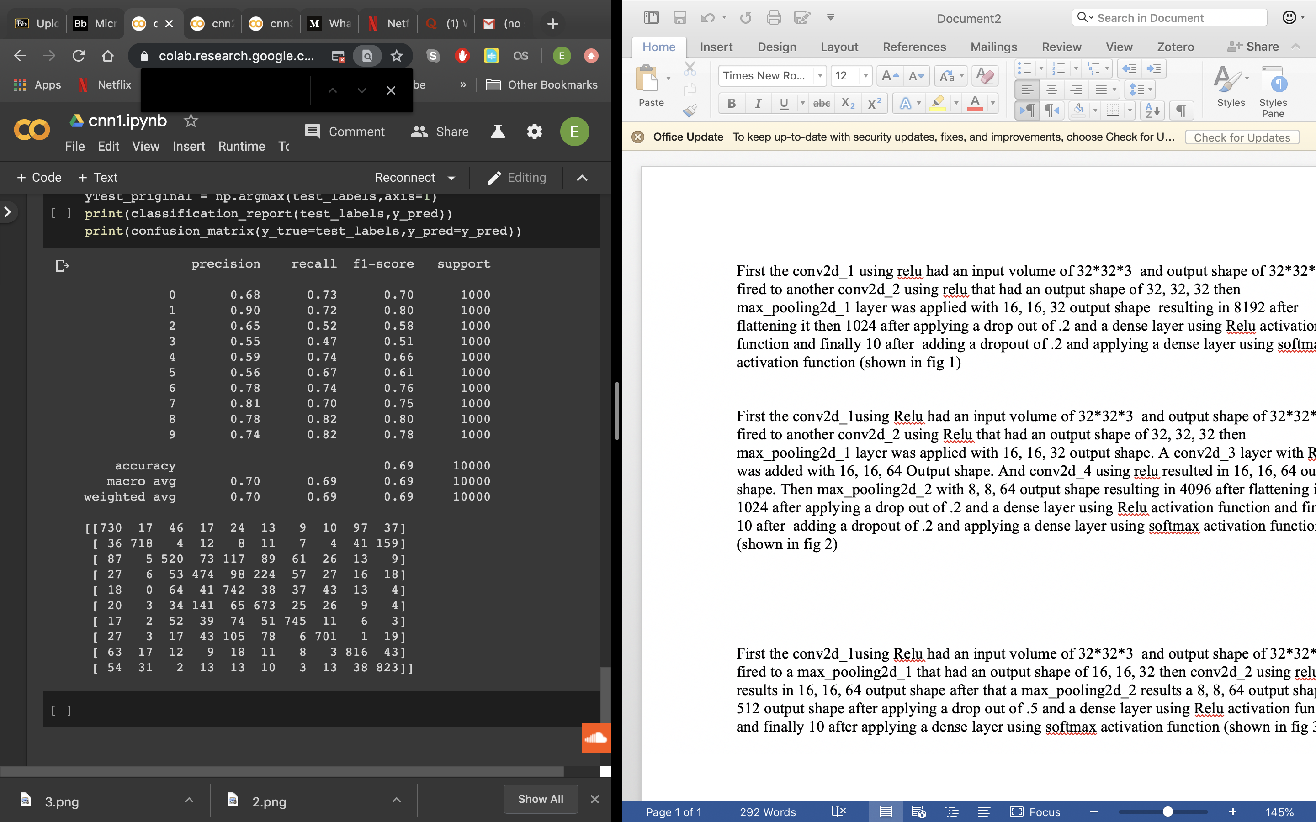

recall: .69

precision: .70

Second structure

First the conv2d_1using Relu had an input volume of 32*32*3 and output shape of 32*32*32 it fired to another conv2d_2 using Relu that had an output shape of 32* 32* 32 then max_pooling2d_1 layer was applied resulted in 16* 16* 32 output shape. A conv2d_3 layer with Relu was added results 16* 16* 64 Output shape. And conv2d_4 using outputs results a 16* 16* 64 output shape. Then max_pooling2d_2 outputs 8*8* 64 resulting in 4096 after flattening it then 1024 after applying a drop out of .2 and a dense layer using Relu activation function and finally an output shape of 10 after adding a dropout of .2 and applying a dense layer using softmax activation function (shown in fig 2)

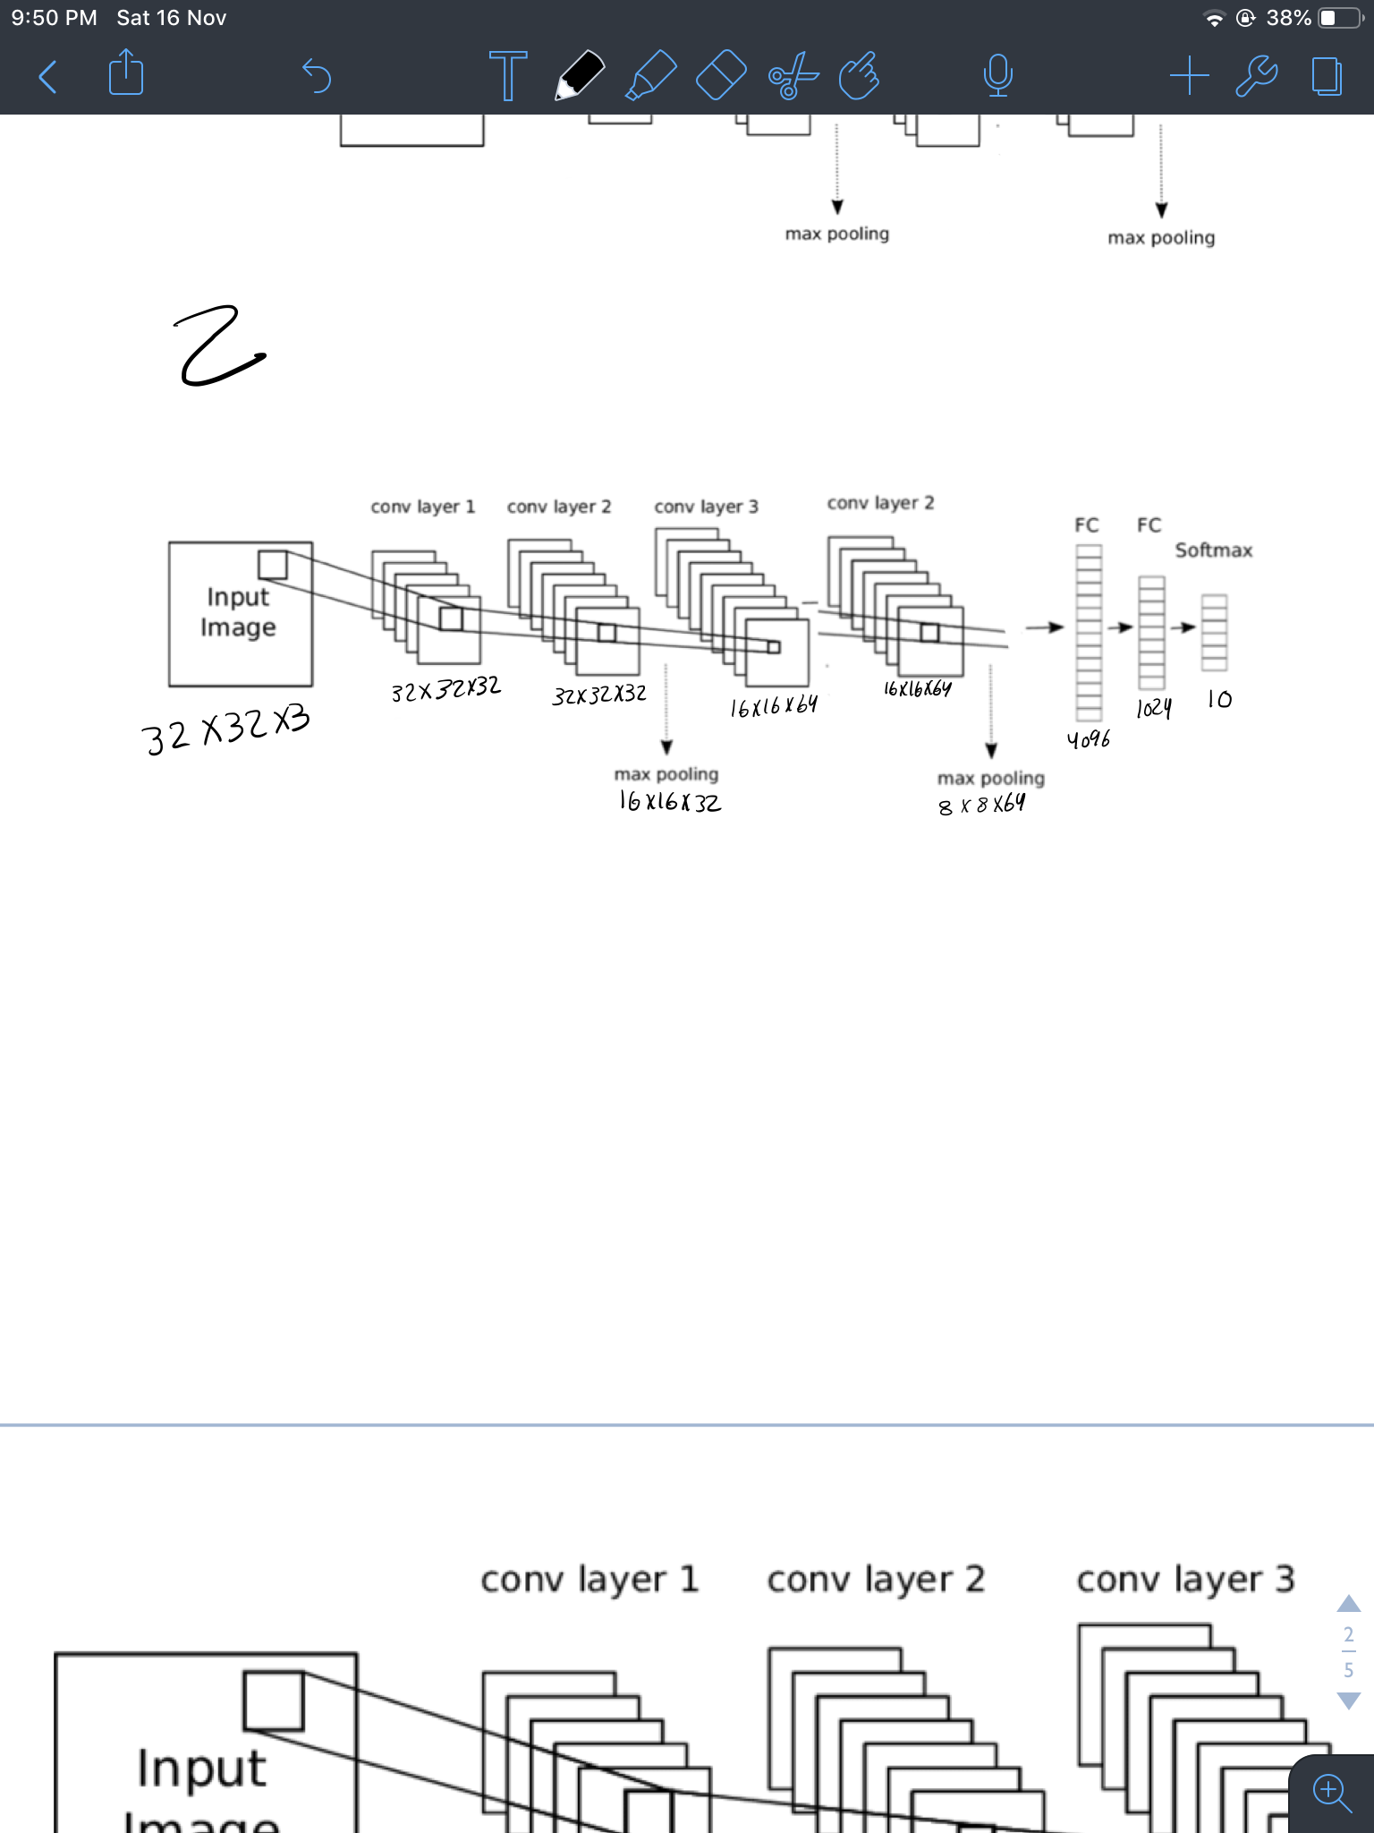

Fig 2

Confusion matrix:

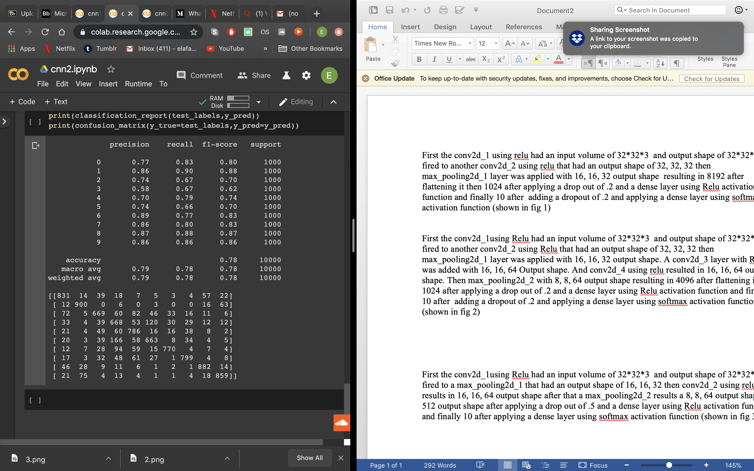

recall: .78

precision: .79

Third structure

First the conv2d_1using Relu had an input volume of 32*32*3 and output shape of 32*32*32 it fired to a max_pooling2d_1 that had an output shape of 16* 16* 32 then conv2d_2 using relu results in 16*16* 64 output shape after that a max_pooling2d_2 results a 8* 8*64 output shape. 512 output shape after applying a drop out of .5 and a dense layer using Relu activation function and finally an output shape of 10 after applying a dense layer using softmax activation function (shown in fig 3)

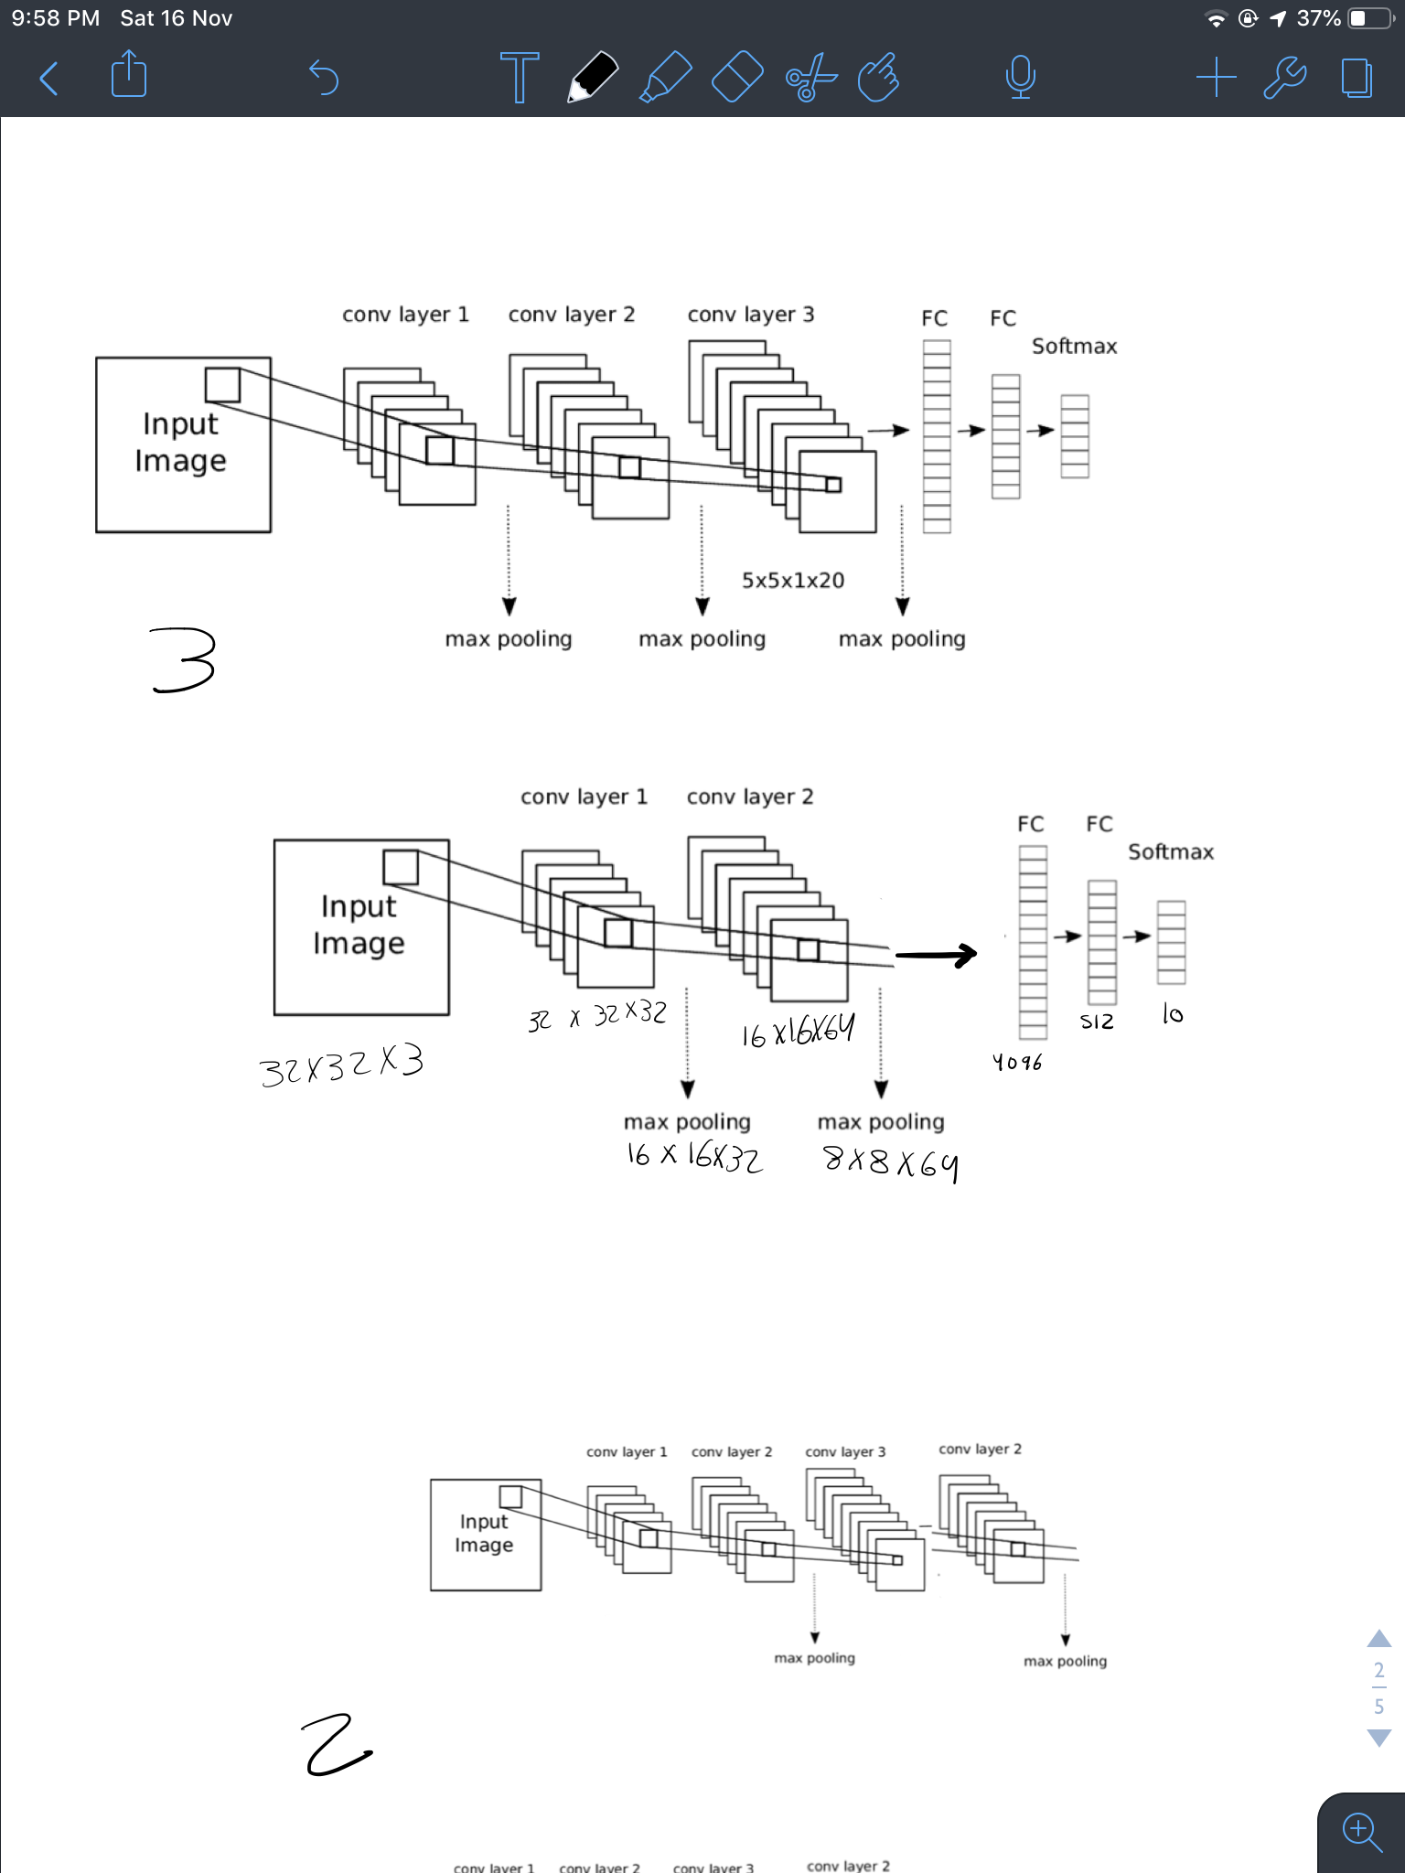

Fig 3

Confusion matrix:

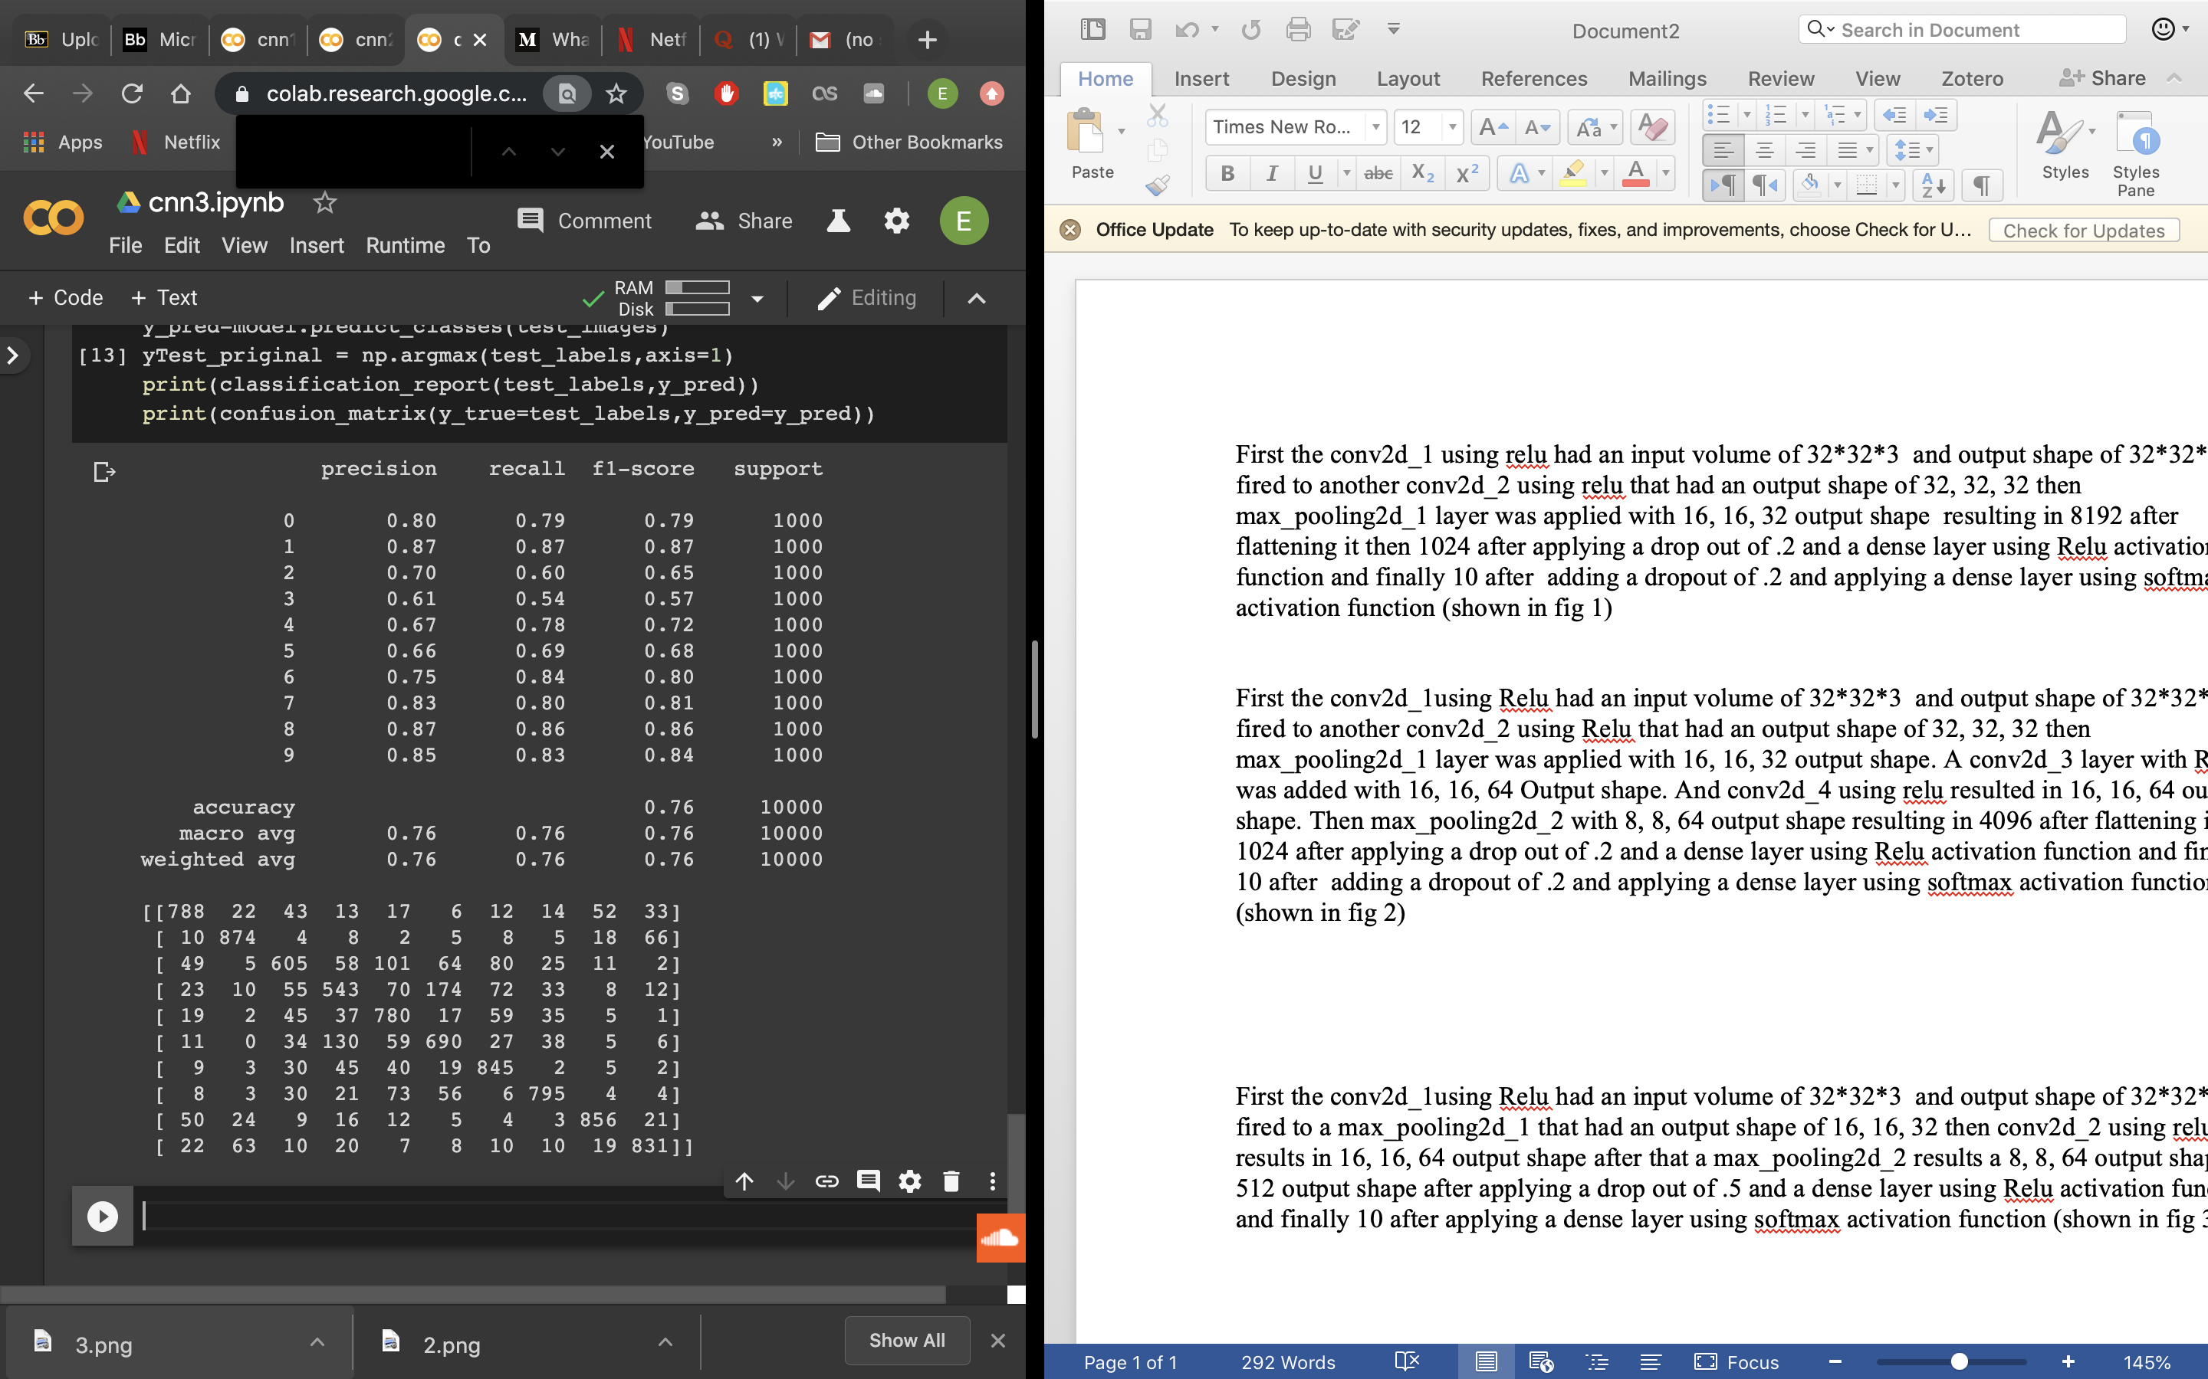

recall: .76

precision: .76

Hence the second structure outperformed the first and the third but all of them suffered from overfitting so in future work regularization will be considered.